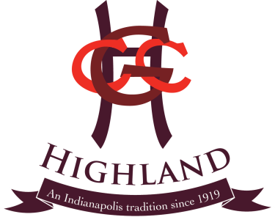
F&B and Catering Director: This key management person will lead the front of the house personnel to provide service that exceeds the expectations of the membership and guests. This person also is responsible for booking member and non member events. Being a high-level member of the Highland team, this individual will be well liked by the members and guests, and work well with the management team.
Key Duties:
- Hire, train, praise and discipline all front of the house personnel including servers, bartenders, pool snack bar & halfway house employees.
- Schedule employees to cover all front of the house activities.
- Ensure that all service experiences exceed expectations.
- Ensure that all member and special events are charged correctly.
- Purchase liquor, soft drinks and wine as required.
- Maintain budgeted bar and labor costs.
- Meet with and book with members for special member events.
- Meet with and book with non members to accommodate sponsored non member events.
- Order front of the house employee uniforms as needed.
- Help with menu design and input into the Jonas system.
- Maintain and set up audio visual equipment as necessary
- Opening and lock up duties as required.
- Any other duties and project assign by the GM
Reports to: GM
Qualifications: This position requires a minimum of 2 years of management in a fine dining operation. Current liquor license.
Compensation: $65,000 base salary with opportunities to earn bonuses and salary increases based on performance. Health insurance, 2 weeks paid vacation, discounted meals and a great work environment!
Key performance indicators:
Member and guest satisfaction/Labor cost to budget/ Beverage cost to budget/Member dining revenue to budget/Special event revenue to budget

