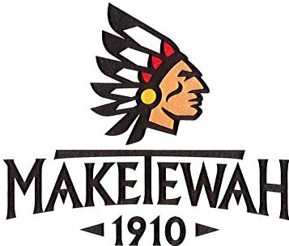

Membership and Marketing Manager

Reports to: General Manager
Job Knowledge, Core Competencies and Expectations
- Marketing and promotions.
- Excellent computer skills.
- Excellent written and verbal communication skills.
- Strong interpersonal and organizational skills.
- Polished, professional appearance and presentation.
- Manage stress and time.
- Effective communication through all department levels and throughout club.
- Knowledge of and ability to perform required role during emergency situations.

Job Summary (Essential Functions)

Job Tasks/Duties
- Plan and implement strategies to meet Club membership and marketing goals.
- Process new Club memberships and all required compliant documentation for submission to Board and/or Membership Committee for approval.
- Conduct tours for prospective members.
- Develop prospective member functions.
- Responsible for all current membership files, requests, upgrades, listings, and any other membership notices/requirements.
- Process member adjustments and resignations.
- Follows-up on marketing efforts and member referrals.
- Maintain and analyze member and marketing data.
- Create Membership and Marketing reports on a regular basis.
- Effectively respond to member comments in accordance with Club standards.
- Develop and provide ideas, feedback, and suggestions to continuously improve the services provided to members.
- Develop, monitor, and adhere to a membership and marketing budget.
- Promote Club activities.
- Track the success and overall performance of all membership and marketing activities.
- Maintain response, attendance, and follow-up lists for all membership and marketing events.
- Attend and Support Membership Committee as required.
- Work collaboratively with Club Board, Membership Committee and members.
- Maintains Club website
- Responsible for all member communications including monthly newsletter and regular emails.
- Completes other appropriate assignments from the General Manager.

Education
- Degree in Marketing or related area of study highly desirable

Candidates may email their Cover Letter and Resume to Mark Bechtel, General Manager at mbechtel@maketewah.com.

